Analyzing Social Resilience using Twitter data under Natural Events vs. Human-Driven Disasters; Is There a Difference?
Saina Sheini
Twitter data offers a giant pool of real-time information, geographically-focused information on different levels of users and tweets. Twitter is designed to ask for “what is happening?” at each moment. With data mining skills, Twitter data can be a great resource of discovering underlying patterns in communities. My research proposal offers a way of analyzing social capital as an indicator of social resilience utilizing geo-tagged and non-geo-tagged tweets. I intend to define measures of social capital in different communities using sentiment and network analysis methods. Of the most important applications of social capital is to show resilience towards disasters. Therefore, the general path of my research is finding patterns of social interactions on Twitter under normal situation and then analyze their changes under the main two types of disasters scenarios: natural events vs. human-driven disasters. I am also interested to find the difference in the “bounce-back to normal life” process after each type of disasters. I will approach this questions by developing metrics of social capital and social resilience using Twitter data. Along with the creation of these methodologies, a tool can be developed to calculate the social capital of each Twitter user and their communities and their online social network. The results of this project would help identify the weaker parts of the communities that need to be considered in resilience planning of the cities.
The tools that I will use in this project are as followed:
- Rstudio: Data cleaning, exploration and manipulation, statistical analysis including regressions and machine learning
- QGIS and ArcGIS: Manipulation and analysis of geo-spatial data
- Tableau: Interactive data visualization
- Python: Scrapping data, backend web development, data analysis and training, and tool development
1 - Social capital metric
I have roughly designed my measures to look as the following figures. Figure 1 represents my first social capital metric. Twitter general attributes as number of followers and followings, likes and retweets have been used to measure social capital in this method
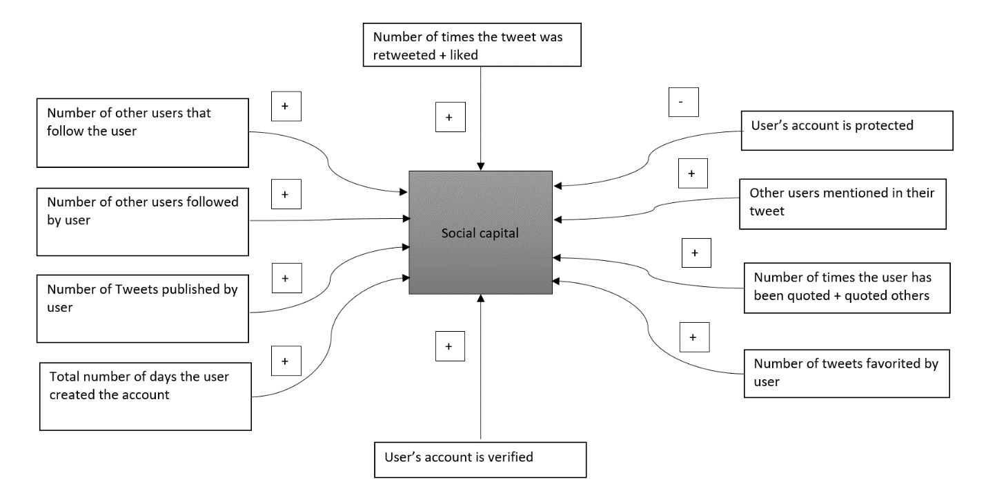
Figure 1. Social Capital Metric on Twitter

2- Sentiment analysis
In the next step, I aim to find discussion topics using information retrieval algorithms as Dynamic Query Expansion for those users. Then, the same process is performed on a population of non-disaster-related tweets. Also, census attributes as age, income, race, etc. can be retrieved for each group. Finally, a regression is performed on census tract data and internal attributes. Then the results of the three datasets can be compared for each city.
There are a few main areas of activities reflecting the normal situation of the community (Gal, 2014). Among these areas are the “daily routines” of individuals of a community, economic activities, mental situation and recreational activities. Attending school, going to work, etc. are among the daily routines that all residents would probably do under normal situation. Shopping, bank related tasks, etc. are some of the economic activities that would go on without a pause every day. The mental situation of the residents would also reflect the state of the emergency in the community. Finally, the recreational activities such as nights out, movies, traveling, etc. and the discussions around them are indicators of the business as usual of the community. These areas can be identified by performing text mining techniques on the Twitter data. Not only I can have a baseline of these activities before the disasters, can expect that during the disaster these areas would show up considerably less than before. In addition, I can argue that observing the same patterns in the tweets after the disasters means the state of the community is back to normal.
3- Network analysis
Another way of approaching social resilience using Twitter data is to implement network analysis. In parallel to the previous section on sentiment analysis, the social network of the users on Twitter will be analyzed under the three scenarios of natural events, manmade disasters, and normal situation. I want to discover how social relations operate under different circumstances. This would be helpful to understand the underlying patterns of social resilience.
Looking into the network topology and the number of interconnections enables is to identify the communities in the network and also in part to how the information is propagated (Fornacciari, Mordonini, & Tomauiolo, 2015). However, there is more than that to social networks. They are more than packs of one-to-one interactions. The social network perspective highlights the importance of the structural characteristics of direct and indirect social relations around an individual. Different patterns of connections may represent distinct dynamics and influence the flow of social support resources (Meng, Chung, & Cox, 2016).
Twitter structure is defined in such a way that each user can follow any number of other users (followees), and can be similarly followed by any number of other users (followers). This means that the Twitter relationships are best described as asymmetrical, meaning that in a followee-follower relationship, the follower would receive all public messages published by any the followee (Fornacciari et al., 2015). In public accounts, this is not correct when it comes to replying to other tweets or tweeting at another user. In other words, any user is able to do any of the mentioned activities to any public Twitter account. These characteristics of Twitter enables us as researchers to identify social networks and differentiate between binding and bridging social capital.
The networks of individuals on Twitter can help us define social capital based on the combination of these two: (1) closure: level of connectedness (binding), and (2) brokerage: points the holes within networks out bridged by a specific member of the group (bridging). This concept can also be defined on any geographical level to assess not only the individual’s social capital, but community’s.
The overall steps of the methodology are presented in the following chart:
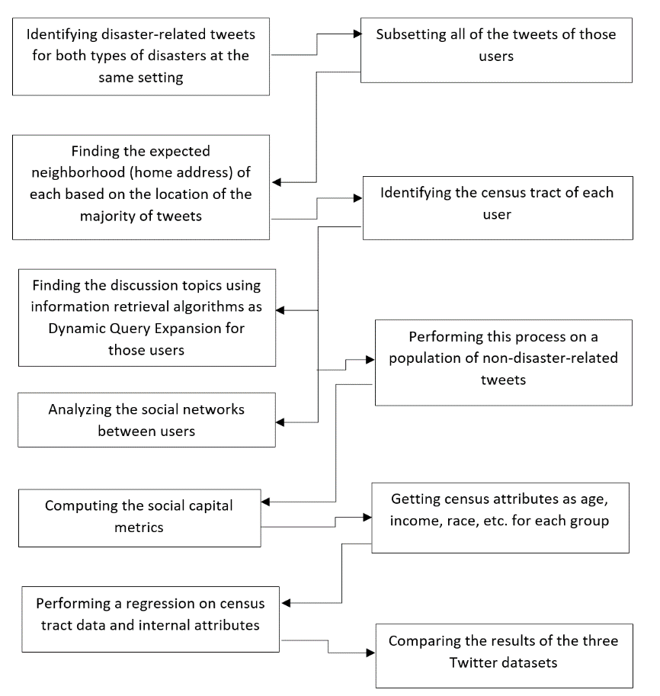
Figure 2. Scheme of the research’s main steps using sentiment analysis and social network analysis
References
Fornacciari, P., Mordonini, M., & Tomauiolo, M. (2015). Social network and sentiment analysis on twitter: Towards a combined approach. CEUR Workshop Proceedings, 1489, 53–64.
Gal, R. (2014). Social resilience in times of protracted crises: An Israeli case study. Armed Forces and Society, 40(3), 452–475. https://doi.org/10.1177/0095327X13477088
Meng, J., Chung, M., & Cox, J. (2016). Linking Network Structure to Support Messages: Effects of Brokerage and Closure on Received Social Support | Journal of Communication | Oxford Academic. Retrieved November 3, 2019, from https://academic.oup.com/joc/article-abstract/66/6/982/4082397

